

From discovery to refinancing and beyond, NestReady helps lenders integrate mortgage and real estate to provide the seamless digital homebuying experience consumers are looking for.

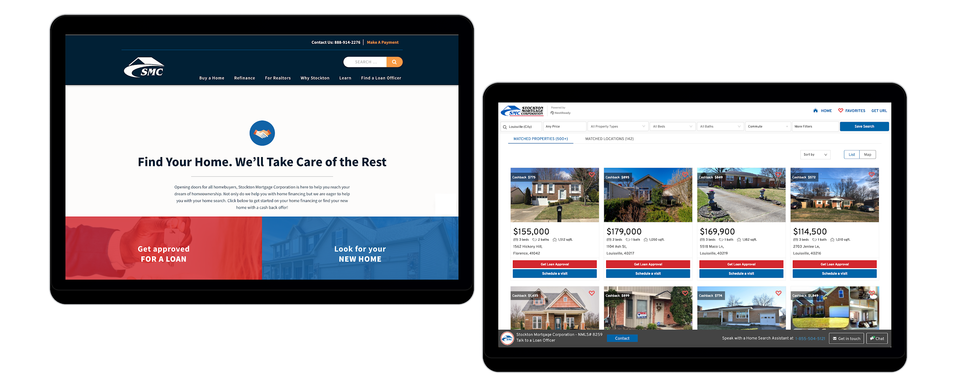

|  |  |  |
| --- | --- | --- |
| **97%**  of U.S homeowners say they find **working with multiple vendors** during the homeownership experience frustrating | **85%**  of homebuyers search for  mortgage before looking for a  home | **27%**  of consumers say end-to-end customer service would convince them to apply for a mortgage with their current bank, **even if it did not offer the best rates** |

**Trusted By**





**Offerings**

|  |  |  |
| --- | --- | --- |
|  |  |  |
| **Loan Officer Platform**  Attract top talent and empower every loan  originator in your organization with a state-of-the-art platform for nurturing leads and supporting clients throughout the homebuying process. |  | **Realtor Platform**  Generate referrals from our realtor network, promote listings, and build relationships with local real estate professionals. |
|  |  |  |
| **NestFinder**  Integrate every step of the homebuyer’s journey into your digital presence with a white-label platform that offers the seamless homebuying experience your clients expect. |  | **NestEngage**  Extend your relationships with clients by providing home profile pages featuring market trends, a refinancing calculator, and other homeowner tools. |
|  |  | **Get up to**  **90%**  **more leads** |
| **NestGrowth**  Deliver a personalized message, at the right time, to the right lead or client with an advanced nurturing system powered by artificial intelligence. |  | Generate your own qualified prospects and become the trusted brand for your clients’ homebuying needs. NestReady customers generate up to 90% more leads on their platforms. |